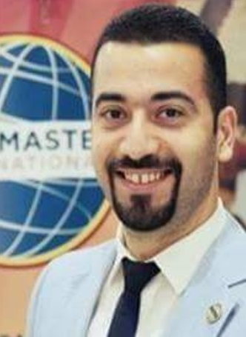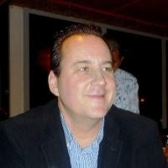**The Transformation**

I started my career journey as a shy person that knows mainly his native language and feels his heart beats during any meeting that involves more than three people.

I tried to increase the number of people who I'm comfortable to talk with at any one time but my attempts were unsuccessful over a period of three years.

Then the research started for an online website solution, coaches and others but all of that was neither attractive nor affordable until I heard about non-profit organization that helps people in improving their public speaking skills called "Toastmasters".

I visited the first club and I was invited to be a Table Topic speaker. That moment I felt something new in myself. Something promising and something adding hope in my life. Immediately, I registered myself with the Vice President Membership who helped me in understanding the basics of the Toastmasters mission.

*The first step:* ***Determination****.*

After few weeks, the election for something called "ExCom" started and the previous team encouraged me to be the Vice President Public Relations. I considered it as a challenge but it was time to know more about club leadership at that stage.

I started to capture the meeting images and publish invitations on our new social media page. During the few next months, the number of guests started to increase and new members joined our club.It was a great experience so I then moved to another club leadership role.

*The second step:* ***Accepting the Challenge****.*

Later, when I discovered that I'd been with Toastmasters for some timeand had developed my communication and leadership skill, I wanted to get higher level of skills and to reach my target. I started seeking advice from our members, mentors and experienced Toastmasters to help me find ways to my goal.

I visited many clubs and had exposure to different experiences that led me to participate in many Toastmasters activities inside and outside of my home club such as training or providing advice to clubs with new members.

I served my home club and other clubs in many ExCom roles (especially VPE) and that gave me the confidence in becoming a reference of knowledge of the Toastmasters leadership handbook, educational track and contest rules.

Now I'm a “bilingual”person I can share knowledge and guidance about Toastmasters toother members, guests and the public in both English and Arabic speaking Clubs.

*Thethird step:* ***Being mentored****.*

This year, I've been nominated and selected by my company to be the host of many corporate events and activities that I would have never expected before joining Toastmasters.

And more recently, I'm honoured to have achieved Toastmasters Educational Awards in both the communication and leadership tracks:Advanced Communicator Bronze (ACB) & Advanced Leader Bronze (ALB). Last but not the least, I'm honoured to accept my latest role in District 105 as a “Pathways Guide” to different clubs.

Yes, I strongly believe that transformed people will transform the others and my story is part of all Toastmasters members in the world. We will improve their experience at a great level of service.That's why transformation is based on great determination of strong will, accepting the challenge to get to higher levels and by getting the experienced mentorship we can reach our targets.

Toastmasters has given me a great opportunity to work with members of different clubs with mutual respect that enhances the integrity amongsteach other. In conclusion, I see that success does not lie in “Results” only but in “Efforts”. “Being” the best is not so important as “Doing” the best…….that is all that matters.

Indeed, Toastmasters IS where leaders are made.

**Why Toastmasters?**

**The First Step - Joining**

Before I ever joined Toastmasters, I went to the inaugural speech held by someone from the “Professional Speakers Association” in London who sent one of their representatives to try and set up a branch in Dubai and to recruit new members from the GCC. The speaker was truly awful putting off most who heard him from joining the PSA, but I did meet a very nice man standing next to me who not only agreed with my view but told me that if I wanted something much better I should attend a “Toastmasters” meeting.

Having never heard of this, I was intrigued and went along the next Wednesday where I was warmly greeted by my fellow sufferer from the week before. I liked the whole agenda and enjoyed being “volunteered” to attempt “Table Topics” which I won (!) but it wasn’t too much of a challenge for me as I was already a “professional” speaker, albeit in my own industry only. I could see how those who had never been on stage before could find it daunting, but it was a supportive and encouraging format rather than a judgemental one, which proved a positive learning experience. I joined the DIC Toastmasters club that day………..

**The Second Step – Joining IN**

It is all very well being a member, but until you give of yourself, are you really engaged? Because Toastmasters teaches its members two tracks - speaking AND leadership, I very soon joined the Executive Committee and started to give back the experience and talent that I have to offer, however minimal. When it comes to bacon and eggs, I followed the mantra that a chicken is interested in breakfast, but a pig is truly involved!

By helping others, I soon found that I was also helping myself because I was learning and being helped too, not only by my assigned mentor but also from the members I was mentoring. Helping others achieve their targets helps one achieve your own goals too.

**The Third Step – Staying in Toastmasters**

Over the years, I have seen people join for a while, get what they want from Toastmasters and then leave. For example, they have been selected to be Best Man at a wedding and need a (temporary) platform to practice. They do not believe that “Givers” gain, only taking what they need at the time, perhaps?

However, like a professional boxer who only fights maybe twice a year, he still needs to spar many rounds during the intervening training period so as to not get “ring rusty”. That is how I feel Toastmasters works for me. By speaking regularly, even if only for a short time during Table Topics (say), I remain comfortable to get on stage at all times. That’s how I was able to address a conference in my profession that had 13,500 people attending earlier this year without “stage fright”.

Having completed all the set tasks given by Toastmasters and having achieved the highest award, other members ask me why I am still involved when so many who are also DTMs are no longer involved, and my answer is always the same: the time to get out of Toastmasters is when you have got everything out of Toastmasters, and who has learned everything already?

And the best thing of all today, is that the guy who introduced me to Toastmasters all those years ago, is still a member of the same club with me. We are both in the ExCom (again!) and we have both found that by giving and doing, we all achieve more…………

**Greg, DTM & TM Tareq**

**DIC Advanced Toastmasters Club**

**Winners - Duo Writing Competition by Division F**

**DIC Advanced Toastmasters Club.**

